1. To download the code, we have written so far just very related to the next step, use the following link.  
   
2. Import all the 3 apps from folder 🡺 98.microservices-starting-point-for-v1-learners
3. One of them is Eureka Server and the other 2 are business microservices so Eureka Clients.
4. These projects are configured with Java 15 but will work with Java 8.
5. 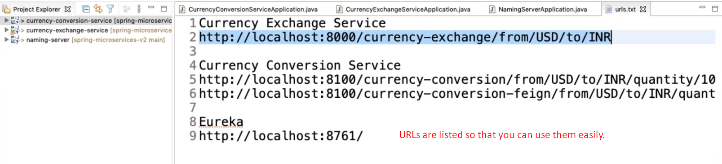
6. 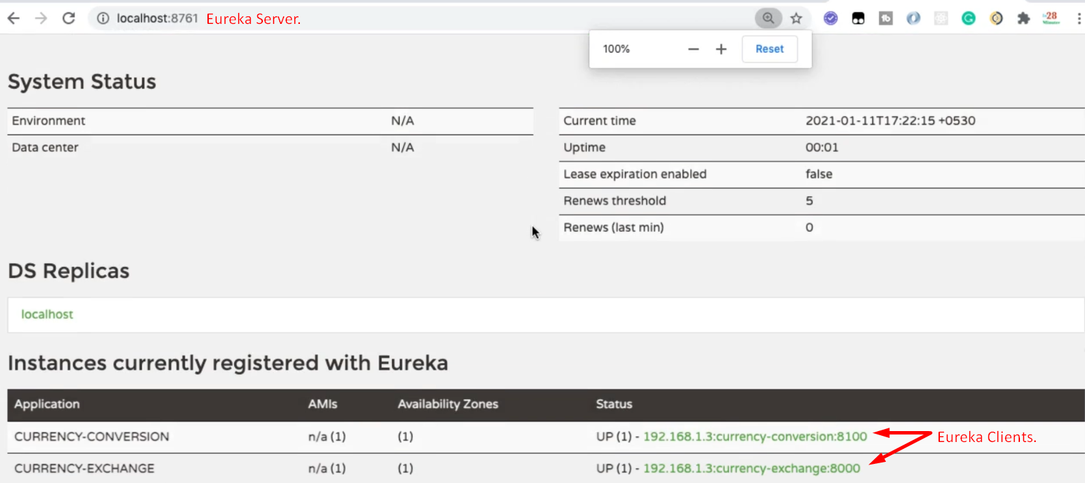
7. 